Activity #3: Network Challenge

Purpose:

Create a functioning network.

Activity:

Using the provided network topology, create different networks so all hosts and routers can communicate with each other. Fill out the tables accordingly, answer questions at the bottom.

Submission Instructions:

* Submit a report (PDF) via Blackboard

Grade Weight: 42 marks [4% of Final Grade]

**NETWORK A** = 192.168.10.0/28  
Default gateway is **first host**  
  
**NETWORK B** = 192.168.20.48/28  
Default gateway is **last host**  
 **NETWORK C** = 192.168.30.80/28  
Default gateway is **first host**  
**NETWORK Y** = 50.40.30.12/30

**NETWORK Z** = 20.10.0.40/30

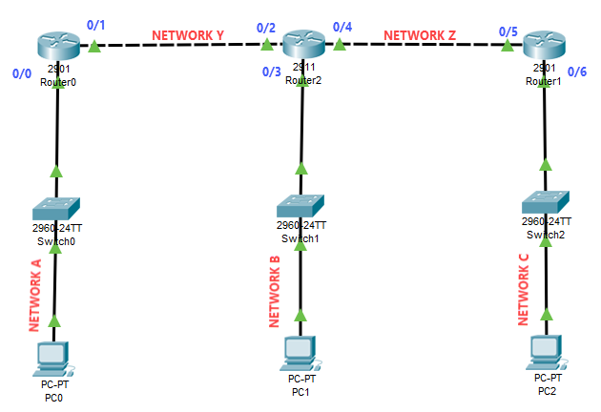

**CLIENT CONFIGURATIONS [9 marks]**

|  |  |  |  |
| --- | --- | --- | --- |
| **DEVICE / PORT** | **IP ADDRESS** | **SUBNET MASK** | **DEFAULT GATEWAY** |
| **PC0** | 192.168.10.5 | 255.255.255.240 | 192.168.10.1 |
| **PC1** | 192.168.20.50 | 255.255.255.240 | 192.168.20.62 |
| **PC2** | 192.168.30.85 | 255.255.255.240 | 192.168.30.81 |

**ROUTER CONFIGURATIONS [14 marks]**

|  |  |  |
| --- | --- | --- |
| **DEVICE / PORT** | **IP ADDRESS** | **SUBNET MASK** |
| **ROUTER0 – 0/0** | 192.168.10.1 | 255.255.255.240 |
| **ROUTER0 – 0/1** | 50.40.30.13 | 255.255.255.252 |
| **ROUTER2 – 0/2** | 50.40.30.14 | 255.255.255.252 |
| **ROUTER2 – 0/3** | 192.168.20.62 | 255.255.255.240 |
| **ROUTER2 – 0/4** | 20.10.0.41 | 255.255.255.252 |
| **ROUTER1 – 0/5** | 20.10.0.42 | 255.255.255.252 |
| **ROUTER1 – 0/6** | 192.168.30.81 | 255.255.255.240 |

**STATIC ROUTE CONFIGURATIONS [12 marks]**

|  |  |  |
| --- | --- | --- |
| **DEVICE** | **NETWORK / CIDR** | **NEXT HOP** |
| **ROUTER0** | 192.168.20.48 /28 | 50.40.30.14 |
| **ROUTER0** | 192.168.30.80 /28 | 50.40.30.14 |
| **ROUTER2** | 192.168.10.0 /28 | 50.40.30.13 |
| **ROUTER2** | 192.168.30.80 /28 | 20.10.0.42 |
| **ROUTER1** | 192.168.10.0 /28 | 20.10.0.41 |
| **ROUTER1** | 192.168.20.48 /28 | 20.10.0.41 |

1. What type of network topology is provided? Explain **[2 marks]**

**Extended Star or Star-Bus**

1. How many hosts can network A support now? **[1 mark]**

**14**

1. What is the valid range of IP addresses for network A? **[1 mark]**

**192.168.10.1-14 /28**

1. What subnet mask is needed for network A to support 30 hosts? **[1 mark]**

**255.255.255.252**

1. What would the new valid range of IP addresses for network A be for the new subnet mask? **[2 marks]**

**192.168.10.1-2 /30**